**Simulation/Verification of CCU**

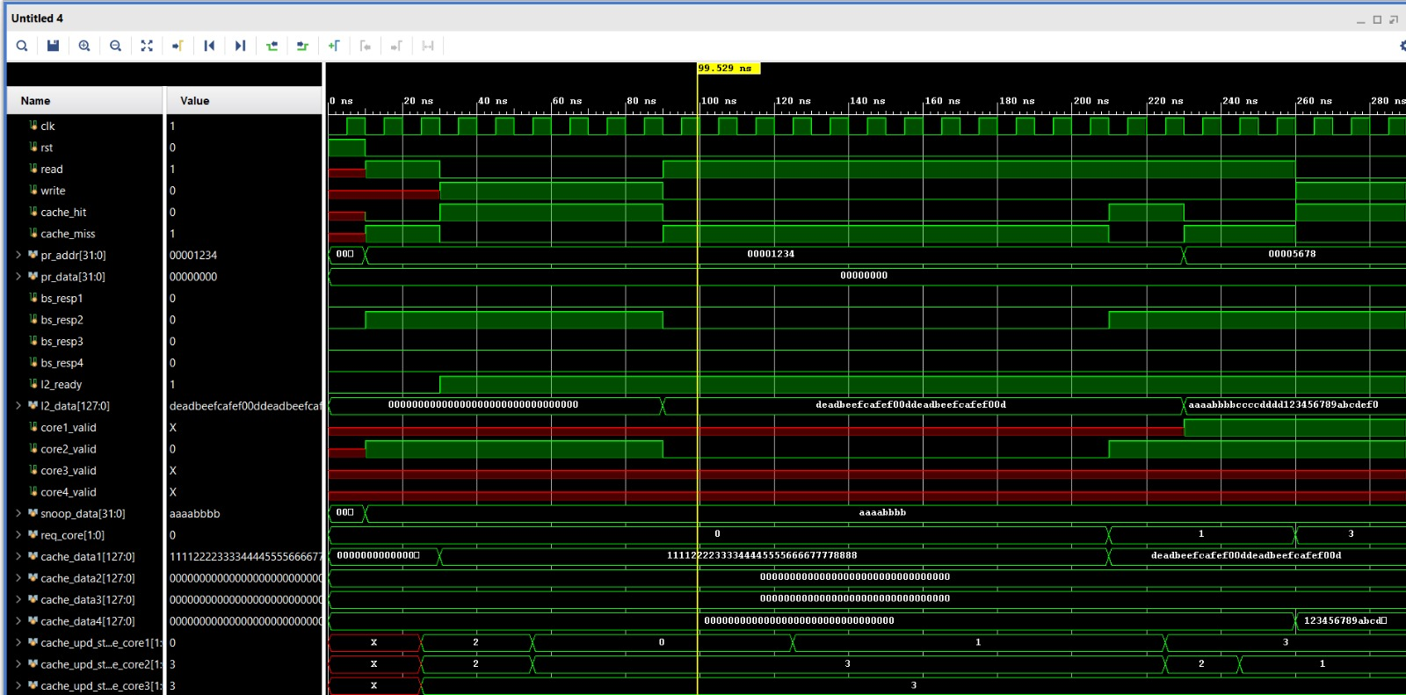 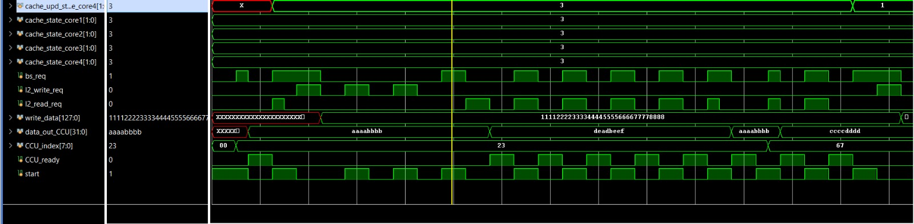

All Tests Passed!